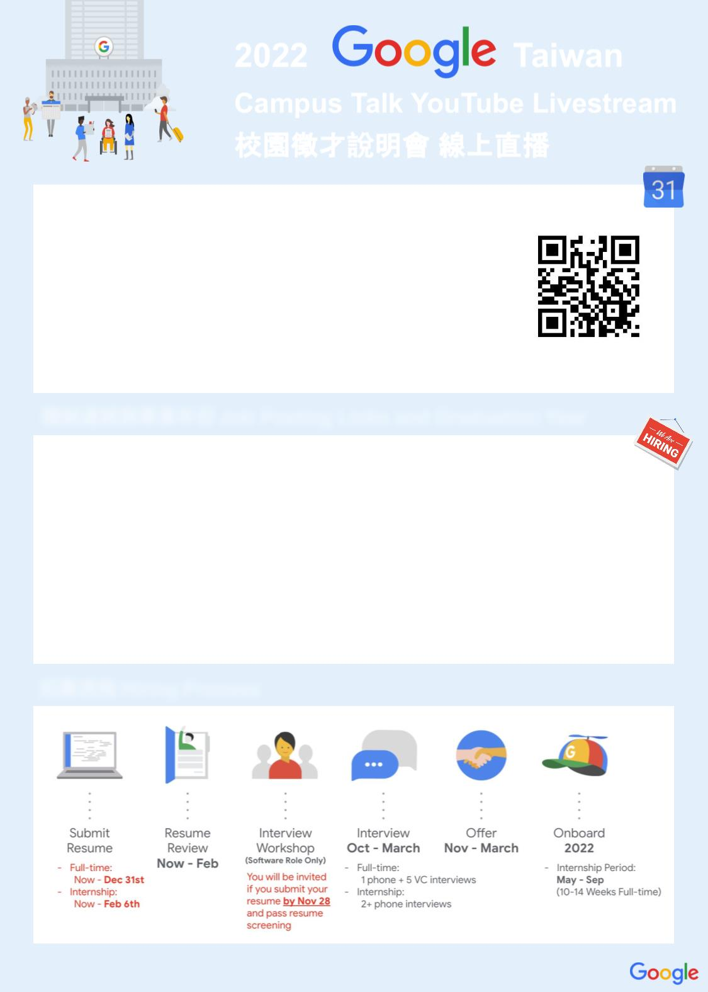

2022
Campus Talk YouTube Livestream
校園徵才說明會 線上直播
Nov 18th Thursday (GMT+8)
16:30-17:15 All about Google Taiwan
17:30-18:15 Career Sharing and Hiring Process
Registration Link will be closed at Nov 14th 24:00
參加說明會就有機會抽中無線充電器、背包、運動毛巾等
Register Now!
神秘精美好禮喔！
職缺連結與畢業年份Job Posting Links and Graduation Year
Full-time
(Graduate in 2022)
-
-
So
Silicon Engineer, University Graduate
Internship
(Graduate in 2023)
-
-
-
-
-
So
Silicon Engineering Spring or Summer Intern
Hardware Engineering Spring or Summer Intern
Mechanical Engineering Intern, Summer Intern
Data Center Technician Intern, Summer Intern
Internship
(Graduate in 2024)
-
Student Training in Engineering Program (STEP) Intern
招募流程 Hiring Process
More information please visit our Campus Site (h
)

